Problem Statement :

As a Full Stack Developer, complete the features of the application by planning the development in terms of sprints and then push the source code to the GitHub repository. As this is a prototyped application, the user interaction will be via a command line.

Background of the Problem Statement :

Company Lockers Pvt. Ltd. hired you as a Full Stack Developer. They aim to digitize their products and chose LockedMe.com as their first project to start with. You’re asked to develop a prototype of the application. The prototype of the application will be then presented to the relevant stakeholders for the budget approval. Your manager has set up a meeting where you’re asked to present the following in the next 15 working days (3 weeks)

* Specification document:Product’s capabilities, appearance, and user interactions.
* Number and duration of sprints required.
* Setting up Git and GitHub account to store and track your enhancements of the prototype. Java concepts being used in the project.
* Data Structures where sorting and searching techniques are used.
* Generic features and three operations:
* Retrieving the file names in an ascending order.
* Business-level operations:
* Option to add a user specified file to the application.
* Option to delete a user specified file from the application.
* Option to search a user specified file from the application.
* Navigation option to close the current execution context and return to the main context.
* Option to close the application.

**Planning**

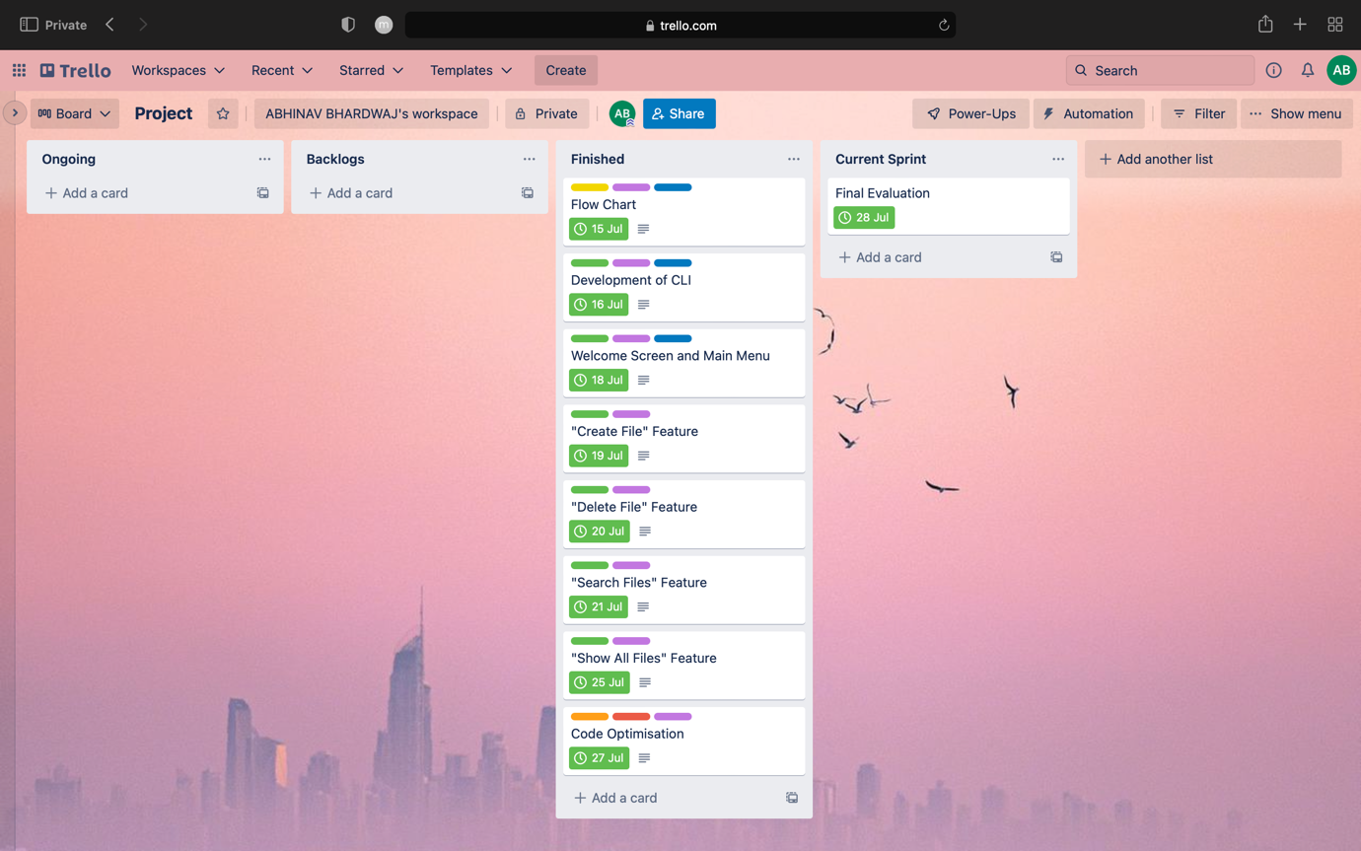

**Design**

User Story :-

Required Features :

* Option to add a user specified file to the application.
* Option to delete a user specified file from the application.
* Option to search a user specified file from the application.
* Navigation option to close the current execution context and return to the main context.
* Option to close the application.

Flow Diagram :-

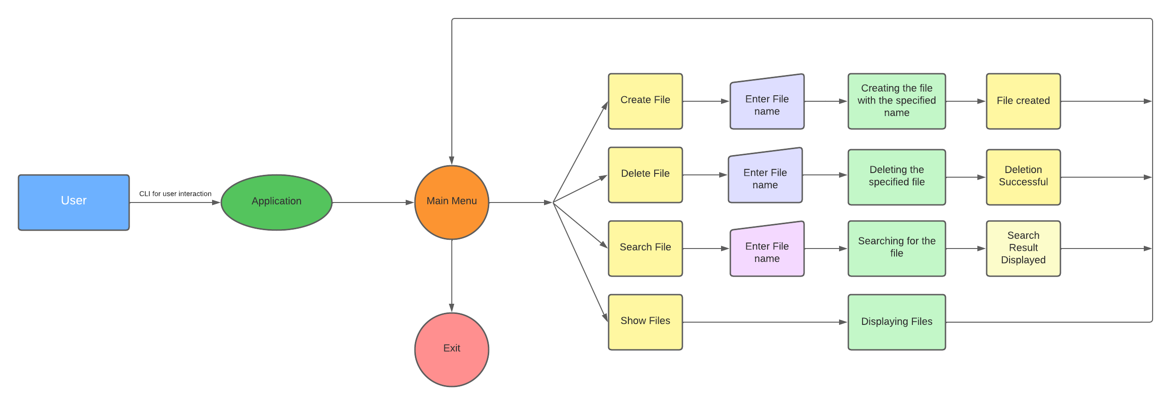

**Coding**

File Tree Structure :-

package virtualKeyForYourRepositories =>

OperationsOverFileDirectory.java

Main.java

OperationsOverFileDirectory.java :-

package virtualKeyForYourRepositories;  
  
import java.io.File;  
import java.util.ArrayList;  
import java.util.Scanner;  
  
*/**  
 * Created by IntelliJ IDEA  
 * User: Abhinav Bhardwaj  
 * Date: 29/07/22  
 * Time: 20:56  
 */*public class OperationsOverFileDirectory {  
  
 ArrayList<String> filesList = new ArrayList <> ();  
 Scanner SC = new Scanner(System.*in*);  
  
 public OperationsOverFileDirectory (String path) {  
 File directoryPath = new File(path);  
 String preExistingFiles [] = directoryPath.list();  
  
 if(preExistingFiles != null) {  
 for (String file : preExistingFiles) {  
 filesList.add(file);  
 }  
 }  
 }  
  
 // To create new file  
 public void createNewFile(String path) {  
 System.*out*.print("Enter the name for the new file: ");  
 String fileName = SC.next();  
 System.*out*.println();  
  
 String filePath = path + fileName;  
  
 File obj = new File(filePath);  
  
 try {  
 if(obj.createNewFile()) {  
 filesList.add(obj.getName());  
 System.*out*.println("Your new file has been created as: " + obj.getName() + "\n\n");  
 }  
 else {  
 System.*out*.println("File name already exists.");  
 }  
 }  
  
 catch(Exception err) {  
 System.*out*.println("Facing issue while trying to create new file as " + err);  
 }  
 }  
  
 // To delete a file  
 void deleteFiles(String path) {  
 System.*out*.print("Enter the file name you want to delete: ");  
 String fileName = SC.next();  
  
 String filePath = path + fileName;  
  
 File obj2 = new File(filePath);  
  
 if (obj2.delete()) {  
 System.*out*.print("\n" + obj2.getName() + " is deleted from the directory.\n");  
  
  
 for (String E: filesList) {  
 if(E.equalsIgnoreCase(fileName)) {  
 filesList.remove(E);  
 showFiles();  
 return;  
 }  
 }  
  
 }  
 else {  
 System.*out*.println("File does not exists !!!\n");  
 }  
 }  
  
 // To search any file  
 ArrayList<String> searchFile() {  
 System.*out*.print("Enter the file name you want to search for: ");  
 String fileName = SC.next();  
  
 ArrayList<String > matchingFiles = new ArrayList<>();  
  
 for (int index = 0; index < filesList.size(); index++) {  
 if (filesList.get(index).equalsIgnoreCase(fileName)) {  
 matchingFiles.add(filesList.get(index));  
 }  
 }  
  
 return matchingFiles;  
 }  
  
  
 // To show  
 void showFiles() {  
 if(filesList.size() == 0) {  
 System.*out*.println("Oops..your directory is empty.\n");  
 return;  
 }  
  
 System.*out*.println("Files present in your directory are: ");  
 for(int file1 = 0; file1 < filesList.size(); file1++) {  
 for(int file2 = 0; file2 < filesList.size() - 1; file2++) {  
 if (filesList.get(file2).compareTo(filesList.get(file2 + 1)) > 0) {  
 String temp = filesList.get(file2);  
 filesList.set(file2, filesList.get(file2 + 1));  
 filesList.set(file2 + 1, temp);  
  
 }  
 }  
 }  
  
 for (String fileName: filesList) {  
 System.*out*.println("\t\t\t" + fileName);  
 }  
 System.*out*.println();  
 }  
}

Main.java :-

package virtualKeyForYourRepositories;  
  
import java.util.ArrayList;  
import java.util.Scanner;  
  
*/**  
 * Created by IntelliJ IDEA  
 * User: Abhinav Bhardwaj  
 * Date: 29/07/22  
 * Time: 20:55  
 */*public class Main {  
 static final String *path* = "./src/FileDirectory/";  
  
 static void welcomeSection() {  
 System.*out*.println();  
 System.*out*.println("*************************************************");  
 System.*out*.println(" Company Lockers Pvt. Ltd. ");  
 System.*out*.println(" Project:- LockedMe.com ");  
 System.*out*.println("*************************************************\n");  
 }  
  
  
 static void exitSection() {  
 System.*out*.println("*************************************************");  
 System.*out*.println(" Thanks for using LockedMe.com Project ");  
 System.*out*.println("*************************************************");  
 }  
  
 public static void main(String[] args) {  
 *welcomeSection*();  
  
 OperationsOverFileDirectory obj = new OperationsOverFileDirectory(*path*);  
 Scanner sc = new Scanner(System.*in*);  
  
  
 while (true) {  
 System.*out*.println("Choose options according to the desired operation.\n");  
 System.*out*.println("\tTo CREATE a new file, choose 1.");  
 System.*out*.println("\tTo SHOW all the files in the current directory, choose 2.");  
 System.*out*.println("\tTo SEARCH for a file, choose 3.");  
 System.*out*.println("\tTo DELETE a file, choose 4.");  
 System.*out*.println("\tTo EXIT from the program, choose 5.\n");  
  
 System.*out*.print("Enter your choice according to your desired operations: ");  
 int choice = sc.nextInt();  
 System.*out*.println();  
  
 switch (choice) {  
 case 1:  
 obj.createNewFile(*path*);  
 break;  
 case 2:  
 obj.showFiles();  
 break;  
 case 3:  
 ArrayList<String> filesList = obj.searchFile();  
  
 if (filesList.size() > 0) {  
 System.*out*.println("\nFiles present with the matching names '" + filesList + "'\n");  
 }  
 else {  
 System.*out*.println("No such file exists.");  
 }  
  
 break;  
 case 4:  
 obj.deleteFiles(*path*);  
 break;  
 case 5:  
 *exitSection*();  
 System.*exit*(0);  
 default:  
 System.*out*.println("Invalid Input !!! Try Again...");  
 }  
 }  
 }  
}